RETAIL CUSTOMER
SEGMANTATION ANALYTICS

TABLE OF CONTENTS

S.NO | PARICULARS | PAGE.NO
01 | Project Objectives | 01
02 | Data Understanding | 02
03 | Data cleaning Process and Transformation | 04
04 | Excel analysis and Formulas | 08
05 | Pivot Table and Pivot Charts | 11
06 | Insights and Report | 13
07 | Conclusion | 15
08 | Dashboard | 16

Retail Customer Segmentation Analytics

Project Objective:
The main objective of this Retail Customer Segmentation Analytics project is to analyze Retail Sales data using Microsoft Excel to understand sales performance, customer purchasing behavior, product performance, and business trends over a specific period. The project aims to transform raw retail transaction data into meaningful information through data cleaning, data analysis, PivotTables, PivotCharts, KPI cards, slicers, and Timeline filters. By analyzing historical sales records, the project helps identify important business patterns, evaluate overall performance, and support data-driven decision-making. It focuses on calculating total sales revenue, identifying the number of orders and customers, measuring the total quantity of products sold, and determining the average order value. These key performance indicators (KPIs) provide a clear overview of the business's sales performance and help management understand how effectively the business generates revenue and serves its customers.
Another important objective of this project is to identify the best-performing and lowest-performing products based on sales revenue and quantity sold. It also aims to compare sales performance across different countries, products, customers, and time periods to identify profitable markets and areas that require improvement. Monthly, quarterly, and yearly sales trends are analyzed to understand changes in revenue and customer demand. This analysis helps identify periods of high and low sales activity, recognize purchasing patterns, and support better planning for inventory, marketing, and business operations. Customer-level analysis is also included to understand purchasing frequency, customer contribution to total revenue, and variations in buying behavior. These insights can help businesses identify valuable customers, improve customer retention, and develop more effective marketing strategies.
The project also emphasizes data quality and accuracy by identifying duplicate records, missing values, invalid data, cancelled invoices, and transactions containing negative quantities. Negative-quantity records are investigated carefully because they may represent product returns, cancellations, or other adjustments. Where appropriate, return transactions are analyzed separately from normal sales to provide a more accurate understanding of business performance. This process ensures that the results are reliable and that important business conclusions are based on properly prepared data. Excel functions, formulas, data validation, sorting, filtering, and PivotTables are used to organize and analyze the dataset efficiently.
Furthermore, the project aims to develop an interactive Excel dashboard that presents key findings in a clear, simple, and visually understandable format. Dynamic KPI cards provide a quick summary of business performance, while charts display revenue trends, country-wise sales, and top- and bottom-performing products. Slicers and a date Timeline allow users to filter the dashboard by relevant dimensions, such as country, year, product, customer, and quality status, depending on the available fields and connected PivotTables. This interactive approach enables users to explore the data from different perspectives and obtain useful insights without manually analyzing the entire dataset.
Overall, the project aims to demonstrate how Microsoft Excel can be used as an effective data analysis and business intelligence tool to convert raw retail data into actionable insights. The final outcome is an accurate, interactive, and user-friendly dashboard that helps stakeholders monitor sales performance, understand customer behavior, identify business opportunities, and recognize areas for improvement. By combining data cleaning, analytical techniques, visualization, and dynamic reporting, this project supports informed business decisions and demonstrates the practical application of data analytics in the retail industry.

Raw Data

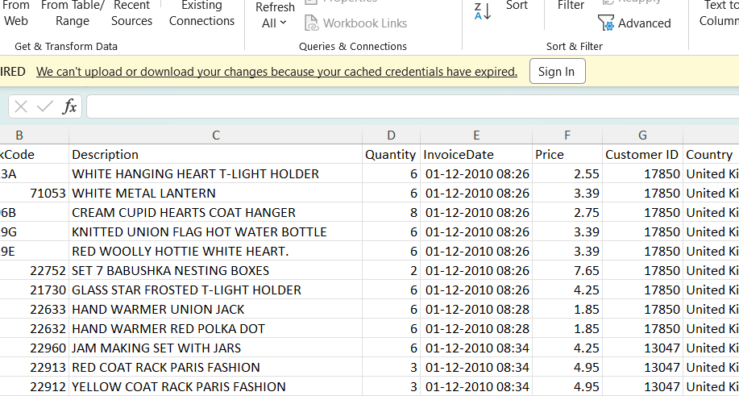

Data Understanding:

Data Sourced By: Kaggle.
Tool Used: Microsoft Excel.
Number of Column:15.
Number of rows: 96459.

Column description:
Column Name | Description
Invoice | Unique invoice or transaction reference used to identify orders.
Stock Code | Unique code assigned to each product.
Description | Name or description of the product sold.
Quantity | Number of units purchased; negative values may indicate returns or adjustments.
Invoice Date | Date and time when the transaction occurred.
Price | Price per unit of the product.
Customer ID | Unique identification number assigned to each customer.
Country | Country where the customer is located.
Sales Revenue | Revenue calculated for each transaction line, generally Quantity × Price.
Quality Status | Indicates whether a record is valid or requires investigation, such as negative-quantity records.
Year | Year extracted from Invoice Date.
Quarter | Quarter of the year in which the transaction occurred (Q1–Q4).
Month | Month name extracted from InvoiceDate.
Month Number | Numeric month value from 1 to 12, used for chronological sorting.
Week Days | Day of the week on which the transaction occurred, such as Monday or Tuesday
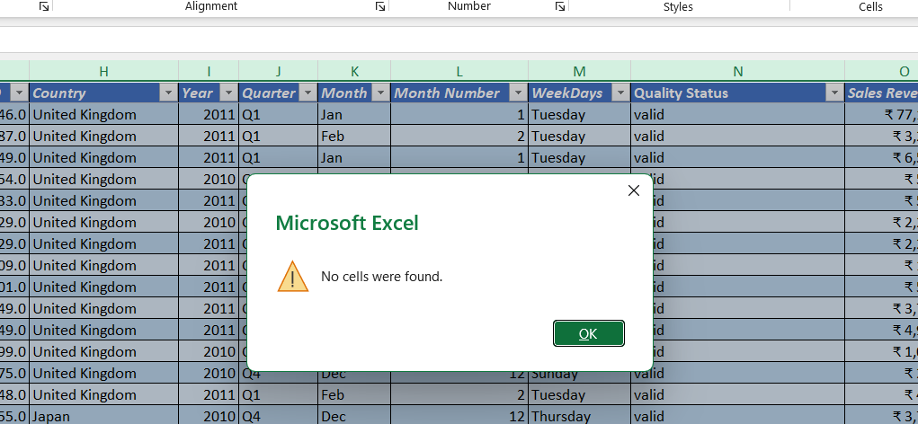
Data Cleaning Process & Transformation

1.Handling Missing Value :
Missing values were identified and checked in the retail sales dataset using Microsoft Excel filters and blank-cell detection techniques. Important columns, such as Invoice, Stock Code, Description, Quantity, Invoice Date, Price, and Customer ID, were examined to understand the extent of missing information. Records with missing values were reviewed carefully before making corrections or removing them. Where possible, missing product descriptions were verified using the corresponding Stock Code, while missing customer IDs were retained when the transaction was otherwise valid and customer identification was not essential to the analysis. Records containing missing or invalid values in critical fields were evaluated based on their impact on sales calculations and reporting. This process helped improve data quality, maintain useful transaction records, and ensure that the final analysis was more accurate and reliable.

2.Duplicate Records Removal:
Duplicate records were identified in the retail sales dataset using Microsoft Excel's Remove Duplicates feature and duplicate-checking techniques. The records were examined using relevant transaction fields, including Invoice, StockCode, Quantity, InvoiceDate, Price, and Customer ID, to distinguish exact duplicate rows from legitimate repeated purchases. Only confirmed duplicate records were removed to avoid accidentally deleting valid transactions containing the same product or invoice details. After removing duplicates, the dataset was checked again to ensure that the remaining records were consistent and suitable for further analysis. This process helped prevent potential overstatement of sales revenue, transaction quantities, and other key performance indicators (KPIs), improving the accuracy of the PivotTables, PivotCharts, and interactive Excel dashboard.

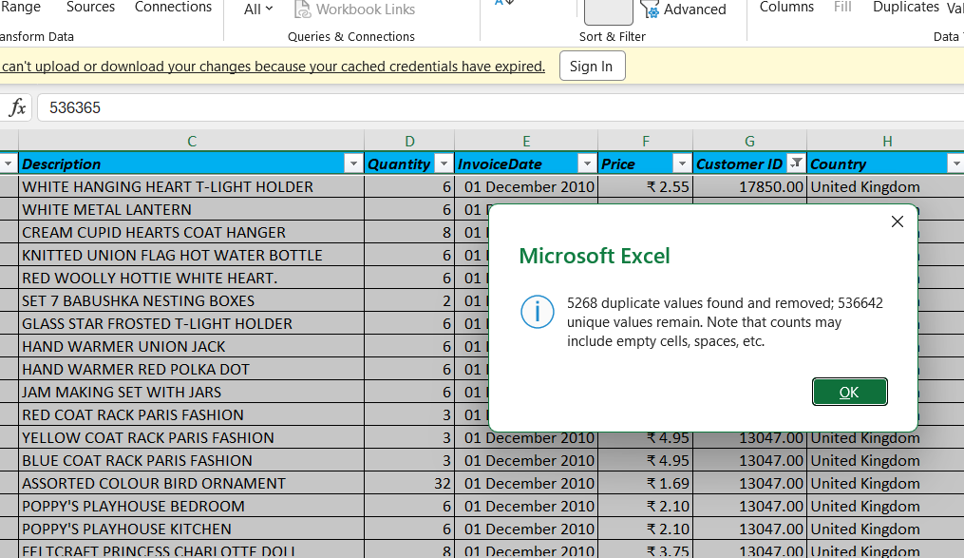
3.Data Type Conversion:
Data type conversion was performed in Microsoft Excel to ensure that each column in the retail sales dataset contained the appropriate data type for accurate calculations and analysis. Invoice dates were converted into a valid date-and-time format, quantity and price columns were converted into numeric formats, and customer and product identifiers were maintained in suitable formats to preserve their original values. The additional date-related columns, such as Year, Quarter, Month, Month Number, and WeekDays, were also checked to ensure consistency. This process helped prevent calculation errors, supported accurate sales revenue analysis, and enabled the creation of PivotTables, PivotCharts, slicers, Timeline filters, and dynamic KPI cards.
Column | Data type
Invoice | General
Stock code | Numbers
Description | General
Quantity | Number
Invoice Date | Date
Price | Currency
Costumer_ID | Number
Country | General
Year | Number
Quarter | General
Month | Text
Month Number | Number
Week Days | Text
Quality Status | General
Sales Revenue | Currency

4.Checking Invalid Values :
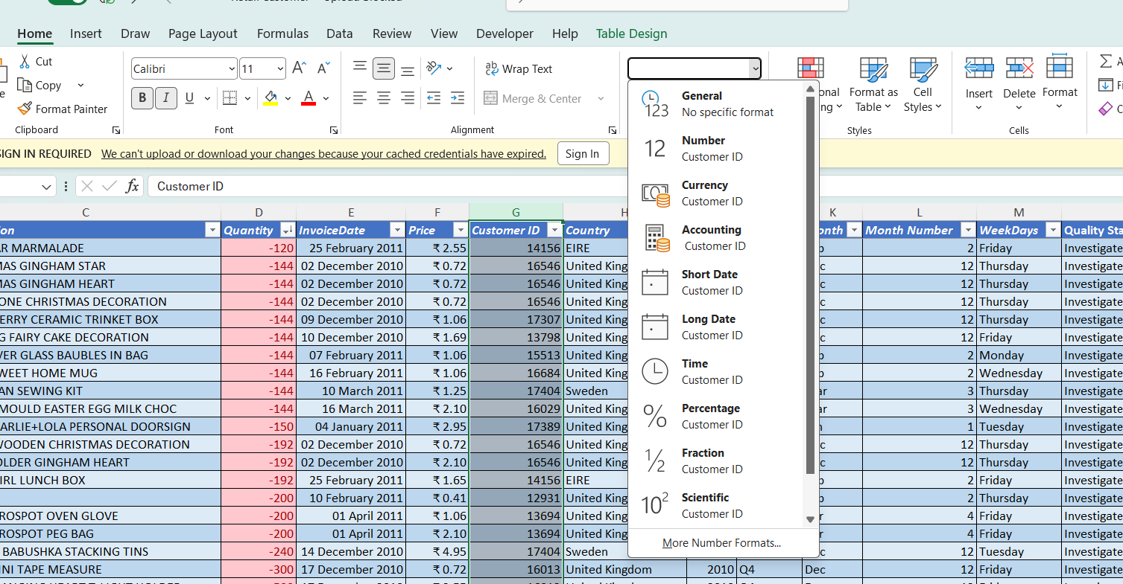
Invalid values were identified and examined in the retail sales dataset using Microsoft Excel filters, sorting, conditional formatting, and validation techniques. The Quantity, Price, Invoice Date, Customer ID, Invoice, and Sales Revenue columns were checked for incorrect, inconsistent, or unexpected values. Negative quantities were reviewed separately because they may represent product returns, cancelled transactions, or other adjustments. Zero or negative prices, invalid dates, missing identifiers, and text values in numeric columns were also examined to determine whether they were genuine business transactions or data-entry errors. The Quality Status column was used to distinguish valid records from records requiring further investigation.
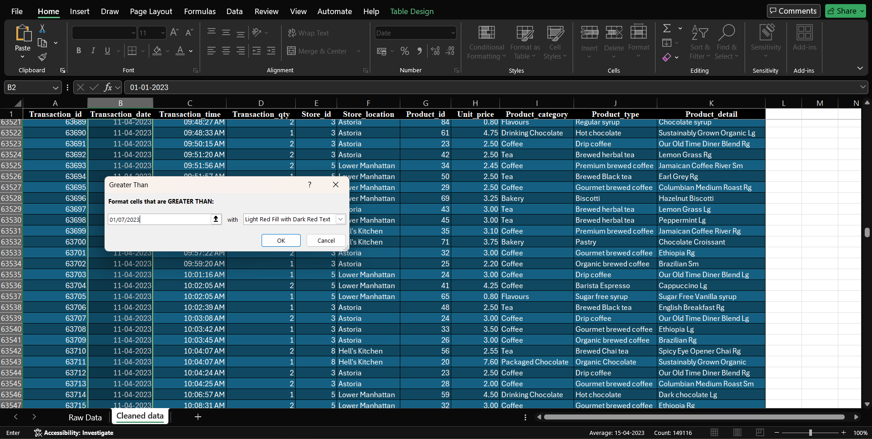

5.Text Standardization:
Text standardization was performed in Microsoft Excel to maintain consistency across text-based columns in the retail sales dataset. Extra spaces, inconsistent capitalization, spelling variations, and unwanted characters were checked and corrected wherever necessary. Functions such as TRIM, CLEAN, UPPER, LOWER, and PROPER were used where appropriate to standardize text values. Columns such as Description, Country, Quality Status, Invoice, and StockCode were reviewed to ensure consistent formatting. Country names and quality status labels were standardized to prevent the same category from being treated as different values during filtering and analysis. Product descriptions and identifiers were handled carefully to avoid changing meaningful product codes or removing important information. This process improved data consistency, reduced duplicate category labels, and supported accurate PivotTables, slicers, charts, and interactive dashboard reporting.
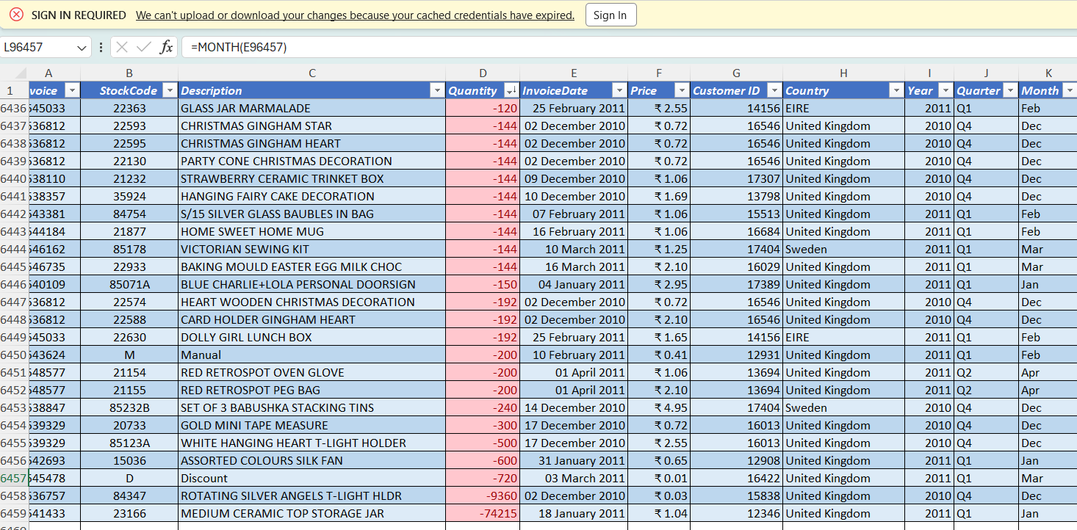

Excel Analysis & Formulas
1. Sales revenue calculation
A new column named Sales Revenue is calculated by multiplying the Quantity by the Price for each transaction line. This measures the revenue generated by each product line and supports analysis of total sales, product performance, and country-wise revenue.
Formula:
=[@Quantity]*[@Price]
2. Total sales revenue using SUM
The SUM function calculates the total sales revenue by adding the values in the Sales Revenue column. This provides an overall revenue figure for the dataset and serves as a key performance indicator (KPI) in the dashboard.
=SUM(RetailData[Sales Revenue])
3. Country-wise revenue using SUMIF
The SUMIF function calculates the total sales revenue for a specific country. For example, it can calculate revenue generated in the United Kingdom by checking the Country column and summing the corresponding Sales Revenue values.
=SUMIF(RetailData[Country],"United Kingdom",RetailData[Sales Revenue])
This formula can be adapted to any country in the dataset.
4. Revenue analysis using SUMIFS
The SUMIFS function calculates revenue based on multiple conditions. For example, it can calculate revenue for a particular product within a selected country. This helps identify product performance in specific markets.
=SUMIFS(RetailData[Sales Revenue],RetailData[Country],"United Kingdom",RetailData[Description],"WHITE HANGING HEART T-LIGHT HOLDER")
5. Average revenue using AVERAGE
The AVERAGE function calcu lates the average revenue per transaction line using the Sales Revenue column. This helps understand the average value of an individual product line. It is not the same as average order value, which requires dividing total revenue by the number of distinct invoices.
=AVERAGE(RetailData[Sales Revenue])
6. Average revenue by country using AVERAGEIF
The AVERAGEIF function calculates the average sales revenue for a selected country. It helps compare the average transaction-line revenue between countries.
=AVERAGEIF(RetailData[Country],"United Kingdom",RetailData[Sales Revenue])
7. Average revenue using AVERAGEIFS
The AVERAGEIFS function calculates average revenue when multiple conditions are applied, such as a selected country and a particular product.
=AVERAGEIFS(RetailData[Sales Revenue],RetailData[Country],"United Kingdom",RetailData[Description],"WHITE HANGING HEART T-LIGHT HOLDER")
8. Invoice record count using COUNTIF
The COUNTIF function counts records matching a specified condition. For example, it can count the transaction lines associated with a particular country.
=COUNTIF(RetailData[Country],"United Kingdom")
This counts transaction rows, not distinct invoices.
9. Record count using COUNTIFS
The COUNTIFS function counts records matching multiple conditions. For example, it can count transaction lines for a particular country with a positive quantity.
=COUNTIFS(RetailData[Country],"United Kingdom",RetailData[Quantity],">0")
This is useful for examining positive-quantity sales records.
10. Revenue classification using IFS
The IFS function classifies revenue into Low, Medium, and High categories based on specified thresholds. This helps group transaction lines according to their revenue value.
=IFS([@[Sales Revenue]]<10,"Low",[@[Sales Revenue]]<50,"Medium",TRUE,"High")
The thresholds of 10 and 50 are illustrative and can be adjusted to suit your analysis. These classifications apply to individual transaction lines, not complete invoices.
11. Quantity classification using IF
The IF function classifies records based on quantity. For example, positive quantities of five or more can be labelled as High Quantity, while smaller positive quantities are labelled as Normal Quantity.
=IF([@Quantity]>=5,"High Quantity","Normal Quantity")
For your dataset, consider handling negative quantities separately before applying this classification.
12. Product information retrieval using XLOOKUP
The XLOOKUP function searches for a product code and returns its corresponding product description. This helps retrieve product information without manually searching the dataset.
=XLOOKUP(A2,RetailData[StockCode],RetailData[Description],"Not Found")
Here, A2 contains the StockCode you want to search for. If the same StockCode appears on multiple rows with different descriptions, the formula returns the first matching description.
13. Month-end date calculation using EOMONTH
The EOMONTH function returns the final date of the month for each invoice date. This supports month-end reporting and time-based analysis.

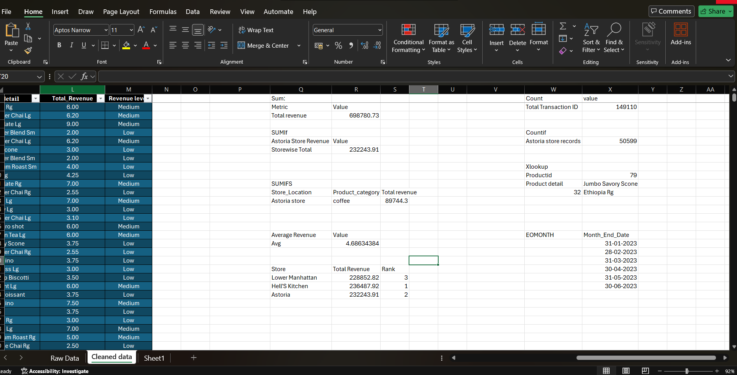

PIVOT TABLES & PIVOT CHARTS
Monthly Sales Revenue
The Monthly Sales Revenue PivotTable summarizes total sales revenue for each month. It helps identify monthly sales trends and compare revenue across different periods.
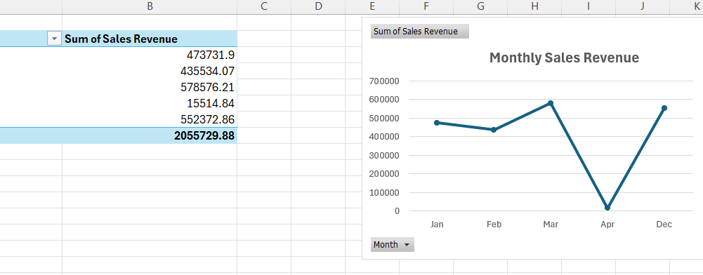
A line chart is used to visualize monthly sales revenue over time. It highlights increases, decreases, peak sales months, and changes in sales performance.
.

2. Top 10 Products by Sales Revenue
This PivotTable ranks products based on their total sales revenue and displays the top 10 highest-revenue products. It helps identify the products that contribute most to overall sales.
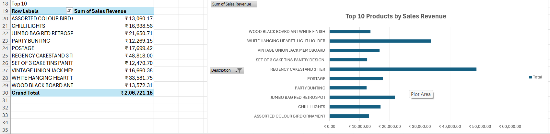
A horizontal bar chart compares the sales revenue of the top 10 products. It makes it easy to identify the highest-performing products and compare their revenue contributions.

3. Revenue by Country
The Revenue by Country PivotTable calculates total sales revenue for each country. It helps compare country-level performance and identify the markets contributing most to overall revenue.
Chart description
A bar chart compares total sales revenue across countries. It highlights the strongest markets and helps reveal differences in geographic sales

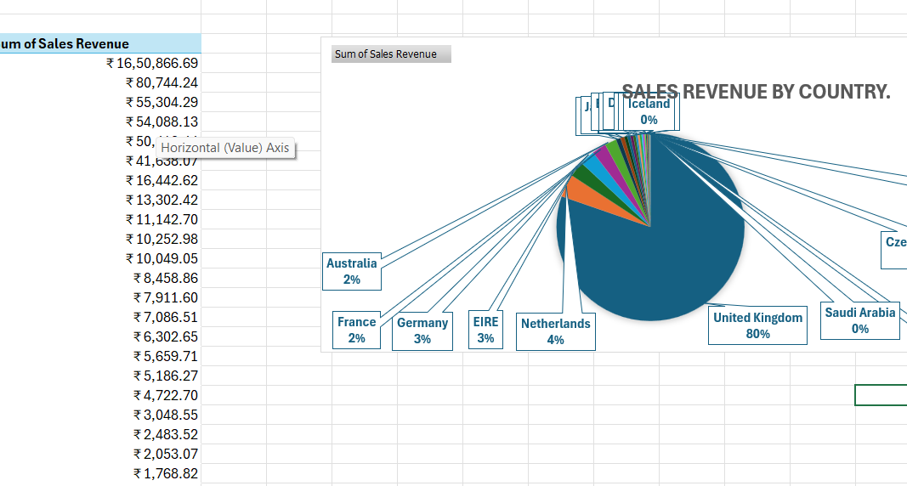

4. Quarterly Sales Revenue
PivotTable description
The Quarterly Sales Revenue PivotTable groups total sales revenue by quarter. It helps evaluate performance across quarterly periods and compare revenue between different parts of the year.
Chart description
A column chart displays total sales revenue for each quarter, making it easy to compare quarterly performance and identify stronger or weaker periods.

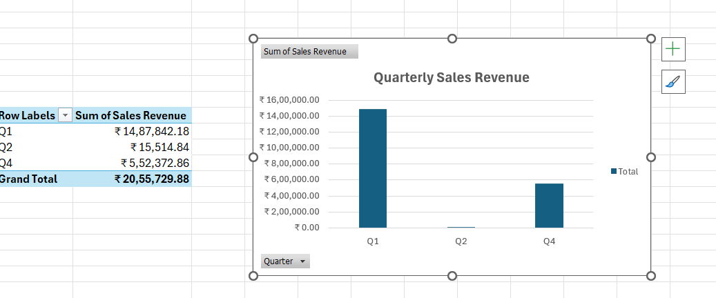

Insights Reports

Key Findings and Business Insights
Monthly sales trends
The dataset covers approximately five months, allowing sales performance to be compared over time. The monthly revenue line chart helps identify peak months, low-performing months, and possible changes in demand.
Business recommendation: Use the validated monthly trend to plan stock replenishment, promotions, and staffing around periods of higher demand.
Top-performing products
Ranking products by total sales revenue identifies the products that contribute most to recorded sales. A Top 10 horizontal bar chart makes it easier to compare product performance.
Business recommendation: Review stock availability and demand patterns for leading products. Compare revenue with quantity sold before making inventory decisions.
Bottom-performing products
The Bottom 10 analysis highlights products with the lowest recorded revenue under the selected ranking method. Low revenue does not automatically mean a product is unprofitable or unsuccessful.
Business recommendation: Investigate product availability, sales volume, customer demand, and whether the product was sold for only a short period before considering changes.
Country-level sales performance
Comparing revenue across 30 countries helps identify the largest recorded markets and countries contributing less revenue. Revenue rankings should be interpreted alongside order volume and customer activity.
Business recommendation: Examine the factors behind high-performing markets and evaluate whether lower-performing markets have opportunities for targeted promotions or customer acquisition.
Quarterly sales performance
Quarterly analysis summarizes revenue by quarter and supports comparisons across reporting periods. Since the dataset covers only December 2010 to April 2011, some quarters are incomplete.
Business recommendation: Clearly disclose the partial-quarter limitation. Use complete quarters for fair comparisons when more data becomes available.
Customer activity
The reported dataset contains approximately 2,200 unique customer IDs. Customer-level summaries can help distinguish repeat purchasing activity from one-time purchases.
Business recommendation: Identify repeat customers and their purchase patterns, then explore retention campaigns. Treat transactions without customer IDs separately when measuring customer behavior.
Data quality and returns
The earlier workbook review flagged 2,451 negative-quantity rows for investigation. These may include returns or corrections, so they should not automatically be deleted or treated as ordinary sales.
Business recommendation: Report returns separately, validate the revenue calculation, and reconcile KPI totals with the cleaned records before presenting final business conclusions.

Conclusion

The Retail Sales Analysis project demonstrates how Microsoft Excel can be used to transform raw retail transaction data into meaningful business insights. Through data cleaning, Excel formulas, PivotTables, charts, and an interactive dashboard, the project analyzes sales performance, product revenue, country-wise sales, and monthly and quarterly trends.
The analysis helps identify high- and low-performing products, understand sales patterns, and compare revenue across different countries. It also highlights the importance of data quality, accurate KPI calculations, and proper handling of returns to ensure reliable results.
Overall, this project improved my practical skills in Excel, data cleaning, data analysis, data visualization, and business reporting. The final dashboard provides a clear and interactive way to understand sales performance and supports better decision-making in inventory planning, sales strategy, and customer management.

DASHBOARD

OUTPUT:

